**Home Page:**

<!-- main screen[aspectratio:screen] -->

<RelativeLayout

xmlns:android="http://schemas.android.com/apk/res/android"

android:id="@+id/main_screen"

android:layout_width="fill_parent"

android:layout_height="fill_parent"

android:clipToOutline="true"

android:background="@drawable/main_screen"

/>

<!-- drawable/main_screen.xml -->

<vector

xmlns:android="http://schemas.android.com/apk/res/android"

xmlns:aapt="http://schemas.android.com/aapt"

android:width="361dp"

android:height="803dp"

android:viewportWidth="361"

android:viewportHeight="803"

>

<group>

<clip-path

android:pathData="M1 1H360V802H1V1Z"

/>

</group>

<group>

<clip-path

android:pathData="M0 0V803H361V0M1 1H360V802H1V1Z"

/>

<path

android:pathData="M1 1H360V802H1V1Z"

android:strokeWidth="2"

android:strokeColor="#000000"

/>

</group>

</vector>

**IMAGE:**

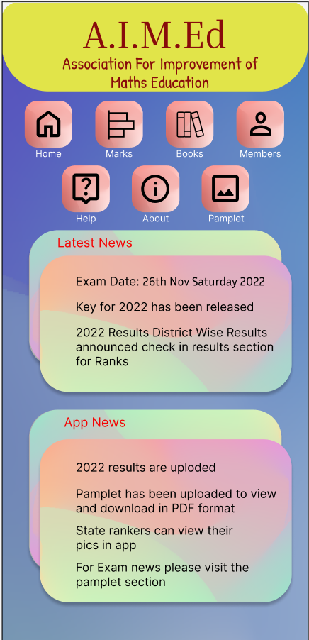

**MARKS TAB**

<!-- Marks[aspectratio:screen] -->

<RelativeLayout

xmlns:android="http://schemas.android.com/apk/res/android"

android:id="@+id/marks_aspec"

android:layout_width="fill_parent"

android:layout_height="fill_parent"

android:clipToOutline="true"

android:background="@drawable/marks_aspec"

/>

<!-- drawable/marks_aspec.xml -->

<vector

xmlns:android="http://schemas.android.com/apk/res/android"

xmlns:aapt="http://schemas.android.com/aapt"

android:width="362dp"

android:height="802dp"

android:viewportWidth="362"

android:viewportHeight="802"

>

<group>

<clip-path

android:pathData="M1 1H361V801H1V1Z"

/>

</group>

<group>

<clip-path

android:pathData="M0 0V802H362V0M1 1H361V801H1V1Z"

/>

<path

android:pathData="M1 1H361V801H1V1Z"

android:strokeWidth="2"

android:strokeColor="#000000"

/>

</group>

</vector>

**IMAGE:**

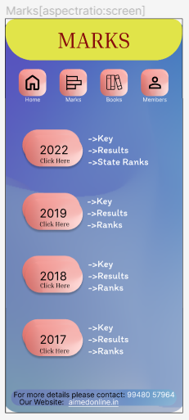

**MARKS PER YEAR**

<!-- 2022[aspectratio:screen] -->

<RelativeLayout

xmlns:android="http://schemas.android.com/apk/res/android"

android:id="@+id/aspectratio"

android:layout_width="fill_parent"

android:layout_height="fill_parent"

android:clipToOutline="true"

android:background="@drawable/aspectratio"

/>

<!-- drawable/aspectratio.xml -->

<vector

xmlns:android="http://schemas.android.com/apk/res/android"

xmlns:aapt="http://schemas.android.com/aapt"

android:width="362dp"

android:height="802dp"

android:viewportWidth="362"

android:viewportHeight="802"

>

<group>

<clip-path

android:pathData="M1 1H361V801H1V1Z"

/>

</group>

<group>

<clip-path

android:pathData="M0 0V802H362V0M1 1H361V801H1V1Z"

/>

<path

android:pathData="M1 1H361V801H1V1Z"

android:strokeWidth="2"

android:strokeColor="#000000"

/>

</group>

</vector>

**IMAGE:**

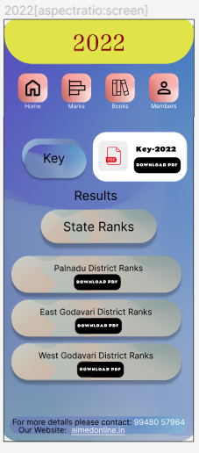

Access to install the PDF file

Next Page

**State Rank Tab**

<!-- Rank -->

<RelativeLayout

xmlns:android="http://schemas.android.com/apk/res/android"

android:id="@+id/rank"

android:layout_width="fill_parent"

android:layout_height="fill_parent"

android:clipToOutline="true"

android:background="@drawable/rank"

/>

<!-- drawable/rank.xml -->

<vector

xmlns:android="http://schemas.android.com/apk/res/android"

xmlns:aapt="http://schemas.android.com/aapt"

android:width="362dp"

android:height="927dp"

android:viewportWidth="362"

android:viewportHeight="927"

>

<group>

<clip-path

android:pathData="M1 1H361V926H1V1Z"

/>

</group>

<group>

<clip-path

android:pathData="M0 0V927H362V0M1 1H361V926H1V1Z"

/>

<path

android:pathData="M1 1H361V926H1V1Z"

android:strokeWidth="2"

android:strokeColor="#000000"

/>

</group>

</vector>

**Specific student Detail with photo**

<!-- state[page:modal:50%] -->

<RelativeLayout

xmlns:android="http://schemas.android.com/apk/res/android"

android:id="@+id/state_page_"

android:layout_width="fill_parent"

android:layout_height="fill_parent"

android:clipToOutline="true"

android:background="@drawable/state_page_"

/>

<!-- drawable/state_page_.xml -->

<vector

xmlns:android="http://schemas.android.com/apk/res/android"

xmlns:aapt="http://schemas.android.com/aapt"

android:width="360dp"

android:height="629dp"

android:viewportWidth="360"

android:viewportHeight="629"

>

<group>

<clip-path

android:pathData="M84 0H276C322.392 0 360 37.6081 360 84V545C360 591.392 322.392 629 276 629H84C37.6081 629 0 591.392 0 545V84C0 37.6081 37.6081 0 84 0Z"

/>

</group>

</vector>

IMAGE:

Hall ticket number is displayed from the

Database

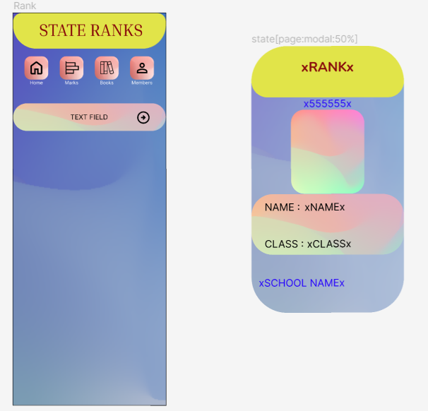

File details from the database

according to the field specified.

Images all will also be accessible

**BOOKS TAB**

<!-- [aspectratio:screen]BOOKS -->

<RelativeLayout

xmlns:android="http://schemas.android.com/apk/res/android"

android:id="@+id/aspectratio"

android:layout_width="fill_parent"

android:layout_height="fill_parent"

android:clipToOutline="true"

android:background="@drawable/aspectratio"

/>

<!-- drawable/aspectratio.xml -->

<vector

xmlns:android="http://schemas.android.com/apk/res/android"

xmlns:aapt="http://schemas.android.com/aapt"

android:width="362dp"

android:height="802dp"

android:viewportWidth="362"

android:viewportHeight="802"

>

<group>

<clip-path

android:pathData="M1 1H361V801H1V1Z"

/>

</group>

<group>

<clip-path

android:pathData="M0 0V802H362V0M1 1H361V801H1V1Z"

/>

<path

android:pathData="M1 1H361V801H1V1Z"

android:strokeWidth="2"

android:strokeColor="#000000"

/>

</group>

</vector>

**IMAGE:**

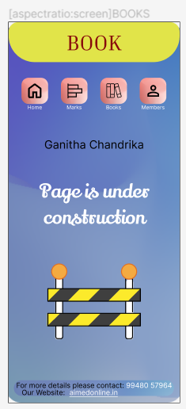

**MEMBERS TAB**

<!-- [aspectratio:screen]MEMBERS -->

<RelativeLayout

xmlns:android="http://schemas.android.com/apk/res/android"

android:id="@+id/aspectratio"

android:layout_width="fill_parent"

android:layout_height="fill_parent"

android:clipToOutline="true"

android:background="@drawable/aspectratio"

/>

<!-- drawable/aspectratio.xml -->

<vector

xmlns:android="http://schemas.android.com/apk/res/android"

xmlns:aapt="http://schemas.android.com/aapt"

android:width="362dp"

android:height="996dp"

android:viewportWidth="362"

android:viewportHeight="996"

>

<group>

<clip-path

android:pathData="M1 1H361V995H1V1Z"

/>

</group>

<group>

<clip-path

android:pathData="M0 0V996H362V0M1 1H361V995H1V1Z"

/>

<path

android:pathData="M1 1H361V995H1V1Z"

android:strokeWidth="2"

android:strokeColor="#000000"

/>

</group>

</vector>

**IMAGE:**

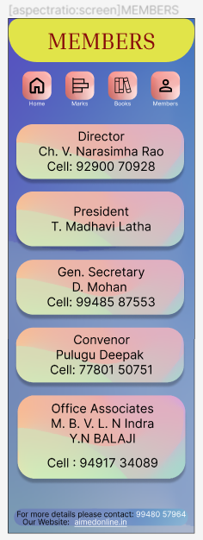

**HELP TAB**

<!-- HELP[aspectratio:screen] -->

<RelativeLayout

xmlns:android="http://schemas.android.com/apk/res/android"

android:id="@+id/help_aspect"

android:layout_width="fill_parent"

android:layout_height="fill_parent"

android:clipToOutline="true"

android:background="@drawable/help_aspect"

/>

<!-- drawable/help_aspect.xml -->

<vector

xmlns:android="http://schemas.android.com/apk/res/android"

xmlns:aapt="http://schemas.android.com/aapt"

android:width="362dp"

android:height="802dp"

android:viewportWidth="362"

android:viewportHeight="802"

>

<group>

<clip-path

android:pathData="M1 1H361V801H1V1Z"

/>

</group>

<group>

<clip-path

android:pathData="M0 0V802H362V0M1 1H361V801H1V1Z"

/>

</group>

</vector>

**About tab:**

<!-- About[aspectratio:screen] -->

<RelativeLayout

xmlns:android="http://schemas.android.com/apk/res/android"

android:id="@+id/about_aspec"

android:layout_width="fill_parent"

android:layout_height="fill_parent"

android:clipToOutline="true"

android:background="@drawable/about_aspec"

/>

<!-- drawable/about_aspec.xml -->

<vector

xmlns:android="http://schemas.android.com/apk/res/android"

xmlns:aapt="http://schemas.android.com/aapt"

android:width="362dp"

android:height="1043dp"

android:viewportWidth="362"

android:viewportHeight="1043"

>

<group>

<clip-path

android:pathData="M1 1H361V1042H1V1Z"

/>

</group>

<group>

<clip-path

android:pathData="M0 0V1043H362V0M1 1H361V1042H1V1Z"

/>

</group>

</vector>

**IMAGE:**

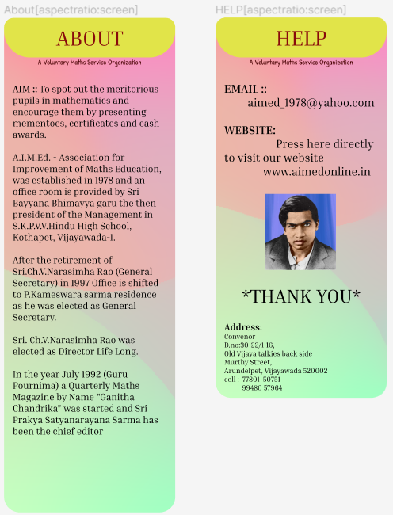

**Brochure TAB**

<!-- Pamplet -->

<RelativeLayout

xmlns:android="http://schemas.android.com/apk/res/android"

android:id="@+id/pamplet"

android:layout_width="fill_parent"

android:layout_height="fill_parent"

android:clipToOutline="true"

android:background="@drawable/pamplet"

/>

<!-- drawable/pamplet.xml -->

<vector

xmlns:android="http://schemas.android.com/apk/res/android"

xmlns:aapt="http://schemas.android.com/aapt"

android:width="362dp"

android:height="2188dp"

android:viewportWidth="362"

android:viewportHeight="2188"

>

<group>

<clip-path

android:pathData="M1 1H361V2187H1V1Z"

/>

</group>

<group>

<clip-path

android:pathData="M0 0V2188H362V0M1 1H361V2187H1V1Z"

/>

</group>

</vector>

**IMAGE:**

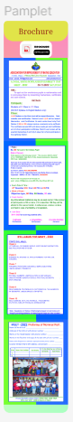

Using scroll user can be

able to see the brochure

and, there is an option

to download and view the

the Brochure

